| Main functionality and Requirement realization | | |  |
| --- | --- | --- | --- |
| Reader Requirements | | |  |
| Requirements | Implementation | Comments |  |
| Organized journal | Totally |  |  |
| Publish four quarterly numbers per year | Totally |  |  |
| a clear master index to the volumes and numbers | Partly |  |  |
| search for a particular paper by title, or by author(s) name(s), or by date interval, or by a subject keyword search | Totally |  |  |
| Clicking on the title of an article should take the reader to the abstract page for that article, giving a summary of the article, email contact details for the authors, subject keywords and a link to download the PDF of the full article | Totally |  |  |
| Readers should be able to register for email notification about papers on particular subject keywords, or for forthcoming editions of the journal, when these are published. | None |  |  |
| facility for readers to send letters to the editor to discuss particular articles | None |  |  |
| Author Requirements | | |  |
| Prospective authors should be able to navigate to a part of the website describing the academic aims and goals of the journal, with a link to details how to submit articles to the journal | Totally |  |  |
| detailed submission guidelines, including document style templates | Partly | Only one style template |  |
| download document style templates, create their article offline using their preferred word processing system then upload their articles in PDF format for review, using a web form | Totally |  |  |
| The information supplied with any article | Totally |  |  |
| Successful submission should be acknowledged by a web page, and an email sent to the main contact author, giving details of their login ID and password | Totally |  |  |
| Login IDs and passwords relate to the unique email address of the contact author, which is maintained in a persistent database | Totally |  |  |
| The same person may use the same login ID for later submitted articles, but access to the journal website will always be restricted to the (tracking; or reviewing) functions that this person is currently expected to perform | Totally |  |  |
| revise the article, and submit a revised PDF, with an accompanying special form | Totally |  |  |
| At least 3 peer-reviews must be completed for each submitted paper, to judge its quality; and 5 reviews are sufficient | Totally |  |  |
| The author’s article may eventually be accepted by the reviewers and the editors; but the author must still complete three peer-reviews of other work | Totally |  |  |
| Reviewer Requirements | | |  |
| There should be a part of the website available only to reviewers, giving clear instructions regarding how to peer-review pending articles, describing what qualities are sought and how to complete the review form | None |  |  |
| A reviewer must login with his (or her) ID and password to obtain access to the part of the website containing unpublished articles that are awaiting peer-review | Totally |  |  |
| Eventually, three articles must be chosen explicitly and peer-reviewed | Totally |  |  |
| If certain articles have been awaiting review for a long time, the system may force the reviewer to select one or more of these, in preference to any other more recent submissions to the journal | Partly |  |  |
| A reviewer may browse pending articles but initially may only read their abstracts, before deciding whether to review the article, by checking a box next to that article. | Totally |  |  |
| Until the articles are downloaded, the reviewer may change his (or her) mind about which articles to review | Totally |  |  |
| The system will keep track of how many articles the reviewer has selected so far for review, and will display these titles to the reviewer, along with their review status | Totally |  |  |
| Periodically, it will send an email reminder to the reviewer, to select more articles, or to submit reviews for chosen articles | None |  |  |
| Once the reviewer has selected one to three articles for review, he (or she) may download the draft PDF versions of those articles, after which he (or she) is committed to review those articles and may not choose to go back, in favour of some other article | Totally |  |  |
| they must submit their review(s) of article(s) using a particular review form | Totally |  |  |
| The review form should contain: an overall judgement , the relevant expertise level of the reviewer (on 3-point scale: expert, knowledgeable, outsider); a summary of the content and novel contribution of the article (as proof that the reviewer has understood it and believes in its good points) |  |  |  |
| a structured criticism of any bad points(issues that the authors must explicitly address in their revision). Each substantive criticism should be described in a separate section of the form, to help editors track authors’ responses to the same criticisms. | None |  |  |
| a detailed list of small errors should be provided for the authors | Partly |  |  |
| The review form should also contain an optional section, allowing the reviewer to send secret comments to the editors | None |  |  |
| Successful review submission should be acknowledged by a web page and an email sent to the reviewer, detailing the content of the review | None |  |  |
| A reviewer should be able to track reviews submitted, and submit a revised review (within a limited time period – say one week), after which the review can no longer be changed, and it is forwarded by the system to the author(s) | Totally |  |  |
| each reviewer will receive from the authors (via the system) a list of detailed corrections describing how he (or she) addressed each of the criticisms highlighted in the review. The reviewer may choose to accept, or reject these changes, by checking off those criticisms that were successfully addressed. | Partly |  |  |
| If accepting, the reviewer may revise the overall judgement on the paper (according to the champion/detractor model). If rejecting, they must explain why the revision is not adequate, and may explicitly highlight further bad points to address in a form. | Totally |  |  |
| A reviewer will not expect to have to go round the corrective and confirming cycle more than twice. If he (or she) still rejects the article after two attempts, it is likely that the article should be rejected overall | Totally |  |  |
| Editor Requirements | | |  |
| The editors are the people who are nominally in charge of running the journal and who host the electronic journal on a website. They must login with their ID and password, which grants them access to the whole site as editors. Their ID identifies them as a current editor | Totally | Totally complete this requirement |  |
| There will be at least one, and possibly many, editors. Any editor may choose to retire, or appoint another person as an editor, so long as at least one editor still exists. | Totally | Totally complete this requirement |  |
| The editor(s) decide upon the title of the journal, its academic aims and goals, and the styles and templates to be adopted for publication | Totally | Totally complete this requirement |  |
| They have an interface which allows these sections of the website to be populated with this standard information. | Totally | Totally complete this requirement |  |
| The editor(s) have access to all the articles; and all the reviews for each article, and to each review form with criticisms, and each author-response to a review. The system must track these, so that it is possible to see the revision history of an article | Partly | Editor can access to all articles and reviews but can not implement track these reviews and history |  |
| The editor may choose to reject a reviewer’s choice of paper to peer-review. In this case, the reviewer must select a different paper to review | Partly | Articles can show all reviews but can not reject review |  |
| The editor may choose to reject an overly brief, hurried review. In this case, the reviewer must resubmit the review | None | Reject function failed |  |
| The editor may choose to reject an author’s revision to an article, which only pretends to include the changes listed in the response to the reviewer(s) | None |  |  |
| The editor may choose to review an article that has been awaiting review for a long time, just to move it through the journal system | Partly | Editor can review an awaiting article but can not move it through the journal system |  |
| If the paper is publishable according to the champion/detractor model, then the editor may publish it officially (as part of the current volume/number of the journal) | Partly | editor can publish articles |  |
| The editor(s) may add published letters to the end of any edition (number) of the journal | None | unfinished |  |

Challenges

1)The challenges that I have met are design and create a unity interface for all web pages. To design a good-looking web page is not a easy work, I have to search a lot of useful website to learn their design and their css style.

2)Another challenge is to achieve editors review and reject function. Editors should get all reviews and articles information from database and then the servlet will handle these data and send back to the web page, but it is difficult to package different data and control the progress of the data changing with mySQL. To solve this problem, I use http session attribute to put the data in the servlet to maintain my servlet or jsp page can get the data and show them on the web page. And to make different kind of data like users , articles and reviews easy to handle, I create some object of them so if I want to get the data, It will be much easier to use ArrayList<object>.

3)In terms of reviewer requirements, system is quiet complicated and in nested structure. Before understanding the good points of 3-Tier layer structure, the only way to avoid producing redundant code and maintain good logical model is to reuse sql sentence within the program as much as possible. In other word, the current work still could be improved by modifying some logic judgement and refreshing browser data totally. Totally speaking, the main requirements of reviewer are implemented, although some function like sending email are still under development.

User’s guide:

1) Editors should login with the editor account and enter Editor center by pressing the button on the top of navigation bar.

2) In the Editor center, there are two main parts. The part on the left are navigation menu that contains Articles, Users, Journals, Waiting Article List and Reviews five buttons. By clicking each button the Editor Center will navigate web page to the aiming page. Editors can also jump back to the home page by clicking the link text under Editor Center title.

The chart below shows the Edit User page, there are three main button on the right middle panel. They are Show all articles, retire and back to editor center button. When editor press retire button, the editor will retire and will no more be the editor.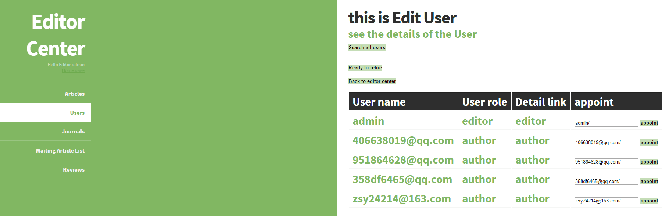

3)Show articles panel ,Journals, waiting article list and reviews panel can show different content by editors’ request. Editor can appoint a new user as editor, edit all journals and articles’ detail, review all articles that have been waited for a long time and reject unfair reviews.

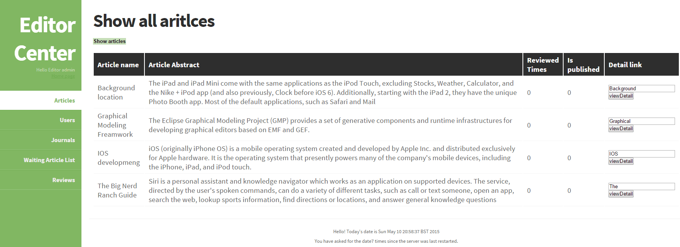

Division of effort: